Hi Arman,
We went through about us section on website and thought we need to redesign and changed content. Please find below correction. Home page correction is after FAQ section. You can go with sequence wise so it would be better for you.
1) Remove Page: We should remove the entire About Us page. Instead, when someone clicks on About Us in the menu bar, a dropdown should appear with the relevant sections. The reason for removing the separate About Us page is that most of the information is already covered on the Home page. Repeating the same content again on the About Us page may feel unnecessary and awkward for visitors.
2) About Us section navigation
About Us
↓
Company Overview
↓
Why Choose Us
↓
Data Security

3) Company Overview: Remove cross mark content written on pic. I felt content is too long for Who We Are so I slightly changed please find below.
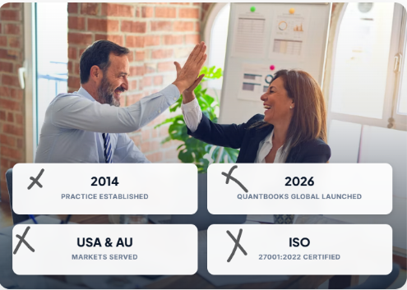

Who We Are: Running an accounting firm today comes with its own challenges. Workloads are increasing, finding the right people is not always easy, and deadlines keep coming. During busy seasons, teams often spend most of their time on handling day-to-day accounting and tax work, leaving little time to focus on client relationships and advisory services.
We started QuantBooks Global with this in mind. We believe outsourcing should be more than just getting routine work done by someone else. The right outsourcing partner should make your workload easier to manage, support your team when you need extra help, and give you more time to focus on your clients
QuantBooks Global provides accounting and tax outsourcing services to CPA, CA, and EA practices, accounting firms, and small and mid-sized businesses across the United States and Australia. We work with your existing systems and processes, understand your requirements, and provide support that fits into the way your team already works.
We see ourselves as an extension of your team, not just another service provider. Our approach is built on four core commitments: Accuracy, Accountability, Integrity, and Excellence
Note: We will follow sequence here to complete page. Please find them below
3.1) Who We Are
3.2) Pathway to Excellence
3.3) Vision and Mission
3.4) Build on Four Principle: I have replaced Security principle with Integrity please find below content for the same and changed on home page as well.
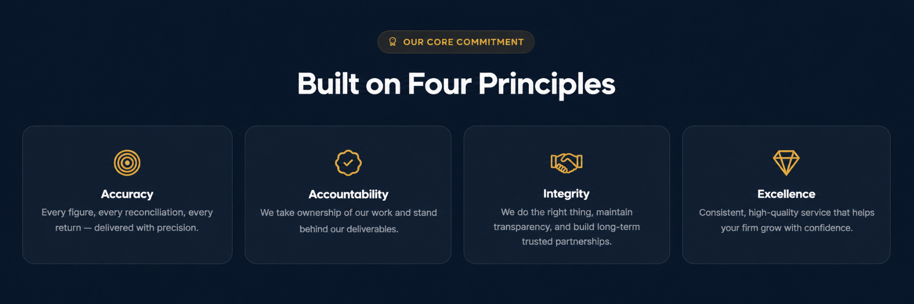

3.5) Meet the Founder: As of now, we have a separate Founder page on the website. However, after considering our current stage and reviewing multiple websites of companies with one or two founders, I feel a separate Founder page is not necessary. In most cases, they include the founders’ bios as part of the Company Overview/About Us section. I believe we should follow the same approach and include our founders’ profiles within the Company Overview rather than maintaining a separate page. This will keep the website more streamlined and avoid unnecessary duplication. Now how you can design founder section please find SS for the same. Below are sample and idea to design. Spell of Ehjaz surname is incorrect please find correct spell : “Ehjaz Savaijiwala”. Please change accordingly.
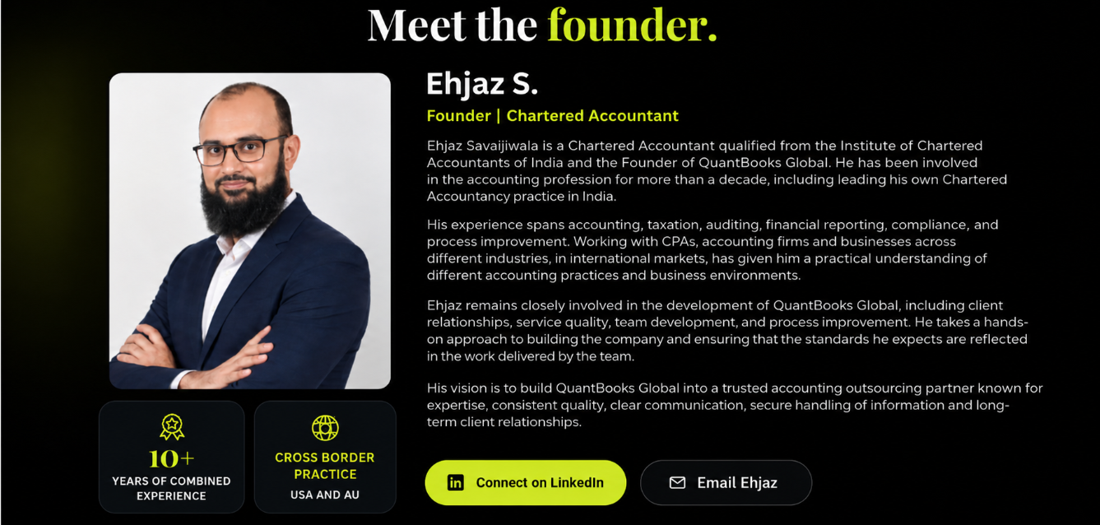
A Message from Our Founder: Good point Armaan to add this and looks professional. I little bit change content on it. Email of Ehjaz : Ehjaz@quantbooksglobal.com.
“Accounting outsourcing cannot simply be about offloading checklists or cutting costs. When a firm trusts us with their client files, they are placing their reputation in our hands. I believe strong accounting support requires true technical mastery, attention to detail, transparent and timely communication, and taking absolute ownership of every single engagement”
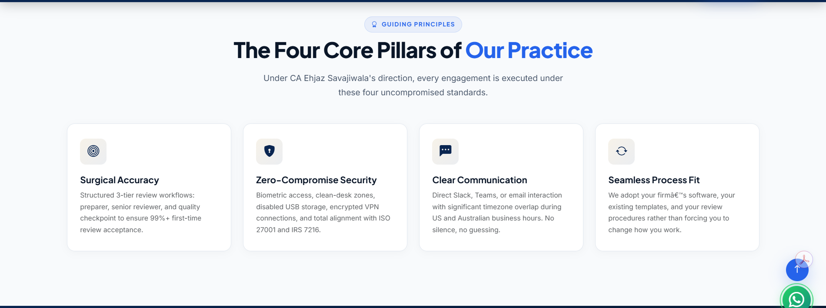
Remove this it’s sound like duplication

3.6) Want to add software behind our outsourced solution over here. For USA software only
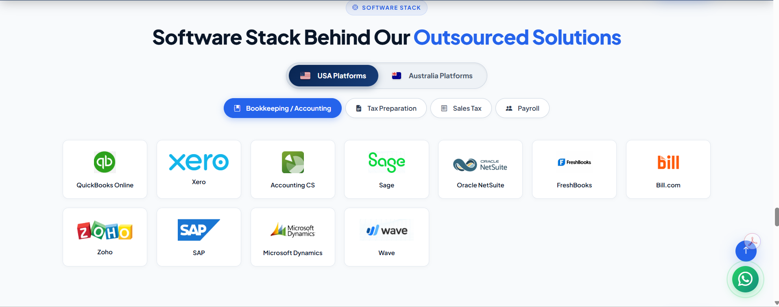
3.7) Inquiry Page
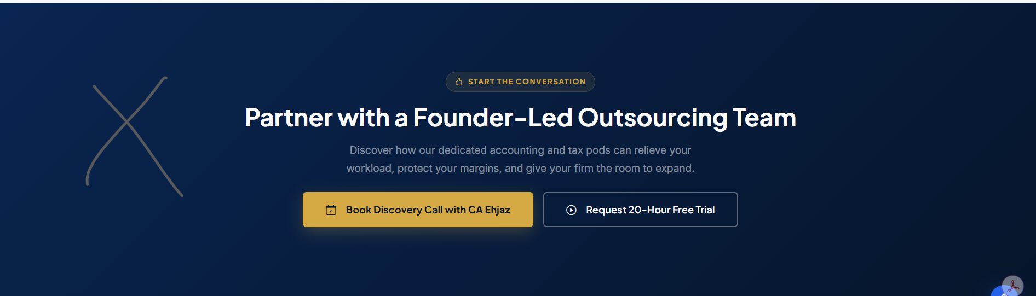


4) Why Choose Us: To avoid duplication of main header content on this page I have reframe that please find below. I have also changed Pera header content and main content.
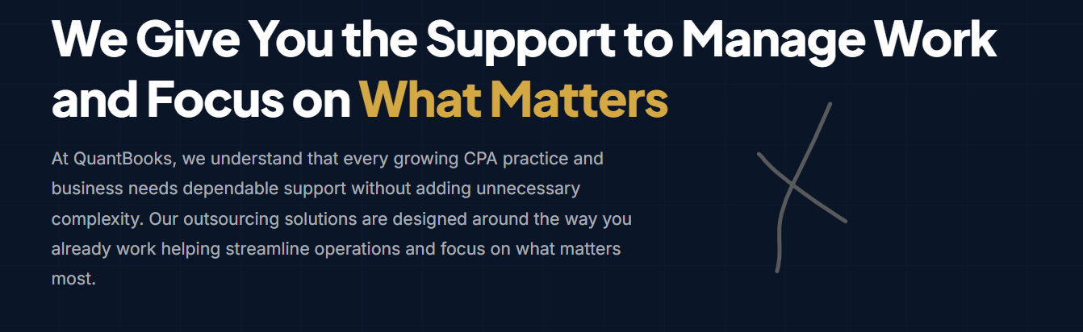
We Give You the Support to Manage Work and Focus on What Matters ❌
We will keep you on right track ✔️
At QuantBooks, we understand that every growing CPA practice and business needs dependable support without adding unnecessary complexity. Our outsourcing solutions are designed around the way you already work helping streamline operations and focus on what matters most. ❌
At QuantBooks, we understand that every growing CPA practice and Business needs reliable support without adding unnecessary complexity. We design our outsourcing solutions to align with your existing workflow, streamlining operations and allowing you to concentrate on what truly matters. ✔️
What Makes QuantBooks Global Different ✔️
No Need to mentioned here click to flip guidance we can keep it simple no content over here.
We will also follow sequence here please find them below
4.1) Why Choose us
4.2) Built on Four Principles: As I replace security and added excellence
4.3) Pathway to Excellence
4.4) Testimonials combined USA and AU
4.5) Inquiry form and schedule a call: Image are below

5) Data Security: To avoid duplication for this content I have made several changes on content please find them below.
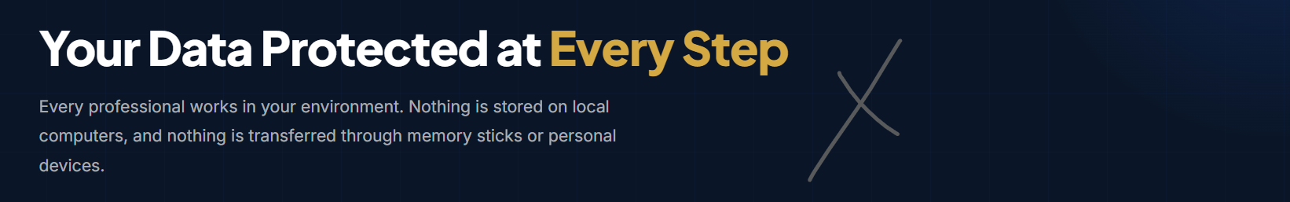
Your Data Protected at Every Step ❌
We Keep Your Data Secure ✔️
Every professional works in your environment. Nothing is stored on local computers, and nothing is transferred through memory sticks or personal devices ❌
We work through secure access to your systems, with controls in place to protect client information throughout the engagement. ✔️
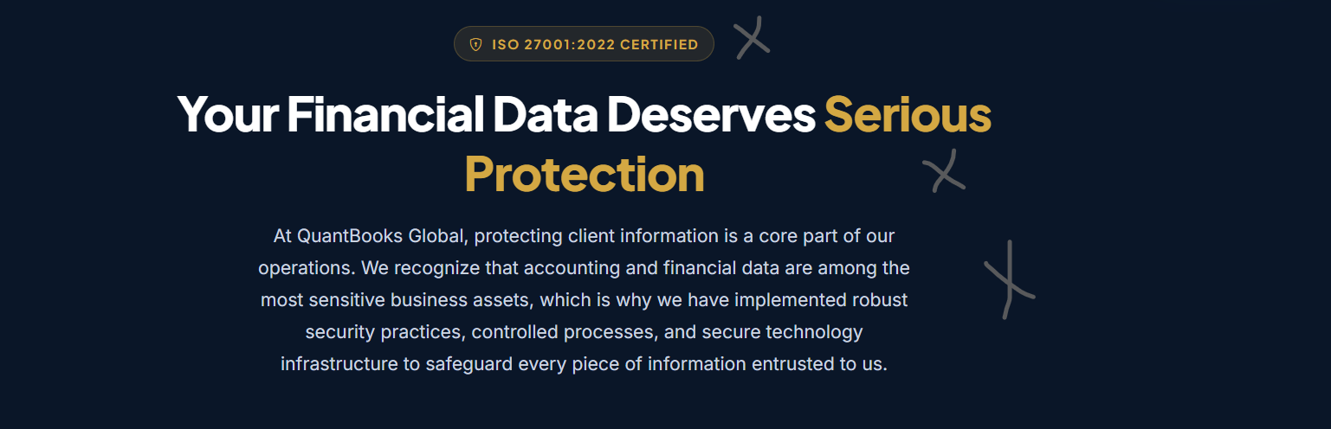
Remove ISO tag from here
Your Financial Data Deserves Serious Protection ❌
How We Protect Your Data ✔️
No change in Pera content just change here for main content

I have changed content of behind flip. Please find them below
Isolated Secure Network ❌
Network Security ✔️
Behind Flip Content of Network Security: Client systems are accessed through secure VPNs, with appropriate security controls in place to protect data and restrict unauthorized access.
Legal Confidentiality & NDA❌
Legal ✔️
Flip content of Legal: Every team member executes a legally binding Non-Disclosure Agreement before engagement. It covers client data and the responsibility to keep all information confidential and secure.

Remove this because it’s already cover on home page
Then we add Inquiry page over here: Idea is below
6) Industries: Just little bit has to change content for both Main and Pera.
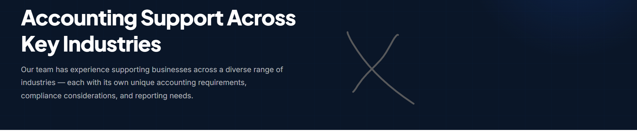
Accounting Support Across Key Industries ❌
Outsourcing Support Built Around Your Needs ✔️

Our team has experience supporting businesses across a diverse range of industries — each with its own unique accounting requirements, compliance considerations, and reporting needs. ❌
We know what your chart of accounts needs to look like, which numbers matter, and where the books usually go wrong. ✔️


So here where is get in touch section will add call link so it would be better and fast for client
Then we want software logos by services combine USA and Australia – Please call me when you reach this section on this, I will guide you to how we want.
Then we add Inquiry page over here: Idea is below

7) FAQs:
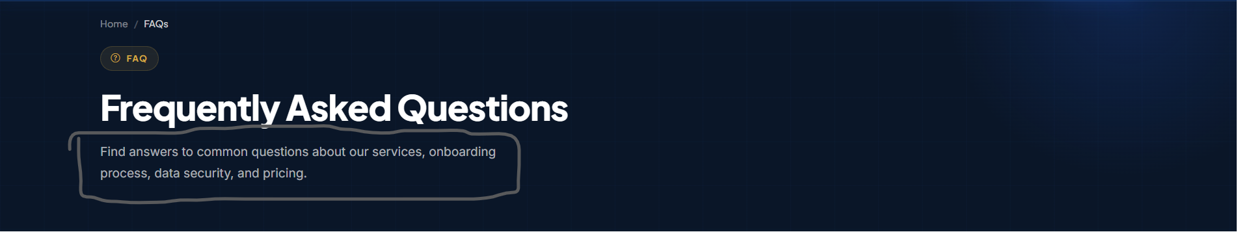
I have mark circle on above page we need to changed content there please find below
Frequently Asked Questions ❌
Everything you need to know before partnering with us. ✔️
Find answers to common questions about our services, onboarding process, data security, and pricing ❌
Twenty-five questions across six categories about us, small and medium businesses, CPAs and accounting firms, getting started, data security, and pricing. Clear answers, no fluff ✔️
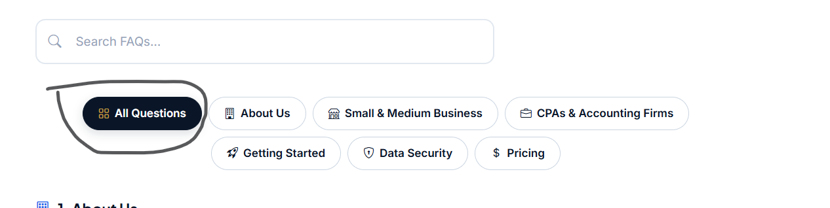

I would request please remove this all-questions tab from here. And please make question design below way. Concept should be same just change presentation.
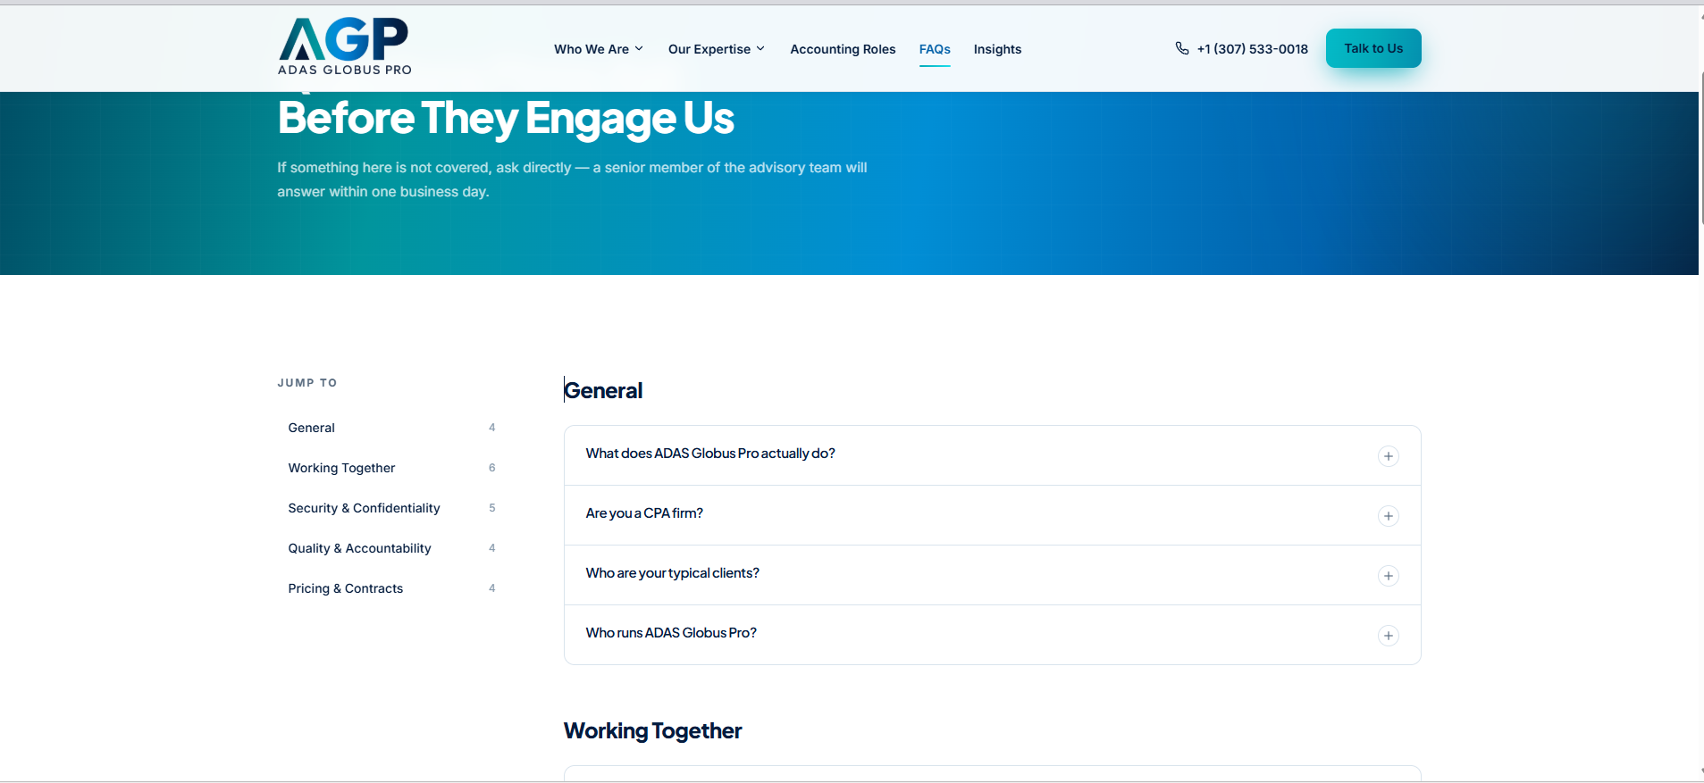

Now find FAQs correction below
  - What is QuantBooks Global?
QuantBooks Global provides reliable and cost-effective outsourced bookkeeping, accounting, tax preparation, sales tax, payroll and virtual CFO support to CPAs, CAs, EAs, accounting firms, small and medium businesses across the United States and Australia.
  - Where is QuantBooks Global based?
QuantBooks Global is headquartered in Ahmedabad, India, where we manage our operations, service delivery, and day-to-day business activities.
  - Why should I have outsourced with QuantBooks instead of hiring in-house employee?
Hiring an in-house employee typically involves salary, benefits, office overhead, and ongoing training expenses. With QuantBooks, you can access experienced accounting professionals at a fraction of the cost without the added overhead of maintaining an in-house team.
2.1 What Outsourcing Services Do You Provide for Small and Medium-Sized Businesses?
We provide comprehensive outsourced accounting solutions to SMBs, including bookkeeping, clean-up and catch-up, sales tax & payroll support, and tax preparation services.
2.3 Can you support businesses in different industries?
Yes. QuantBooks Global supports businesses across a wide range of industries, including e-commerce and retail, healthcare and wellness, real estate and leasing, construction, hospitality and dining, logistics and trucking, pharmaceuticals.
2.4 Can I outsource only single service, or do I need to outsource multiple services?
You can outsource a single service based on your immediate needs. However, if you require support across multiple areas, we can design a customized, cost-effective package tailored specifically to your business requirements.

2.5 Which accounting software do you work with?
We primarily work with QuickBooks Online and Xero. If you use another software, simply let us know during our discovery call, and we will find the best way to work with your existing software.

CPAs and Accounting Firms – This one is right
3.1 Do You Provide Outsourcing Services to CPAs and Accounting Firms?
QuantBooks Global partners with CPAs and accounting firms to provide scalable outsourcing solutions. Our services include bookkeeping, tax preparation support, white-label accounting and virtual CFO services.
3.3 Can you work with our firm's existing processes and instructions?
Yes. We work within your firm's existing processes, instructions, workflows, software, templates, and review procedures, so your team does not have to change the way it works.
3.4 How do you manage the time zone difference between India and USA?
During the discovery call, we discuss your preferred working hours and communication needs, then establish a tailored schedule that ensures sufficient overlap for real-time collaboration and timely support.
3.5 How do you maintain quality and accuracy in outsourced work?
At QuantBooks Global, every engagement is delivered by experienced professionals who follows standardized workflows, defined internal controls, and multiple quality review stages.
3.7 How is white-label bookkeeping different from outsourced accounting?
White-label bookkeeping means we works behind the scenes under your firm's brand, while you retain the client relationship and remain point of contact.
4.1 How do we get started?
We start with discovery call to understand your firm challenges, the services you need support with, your current processes, and your expectations, followed by signing a NDA to ensure confidentiality and trust.
8) Home page: After discussion with Ehjaz we have to change little bit of home page please find that correction below
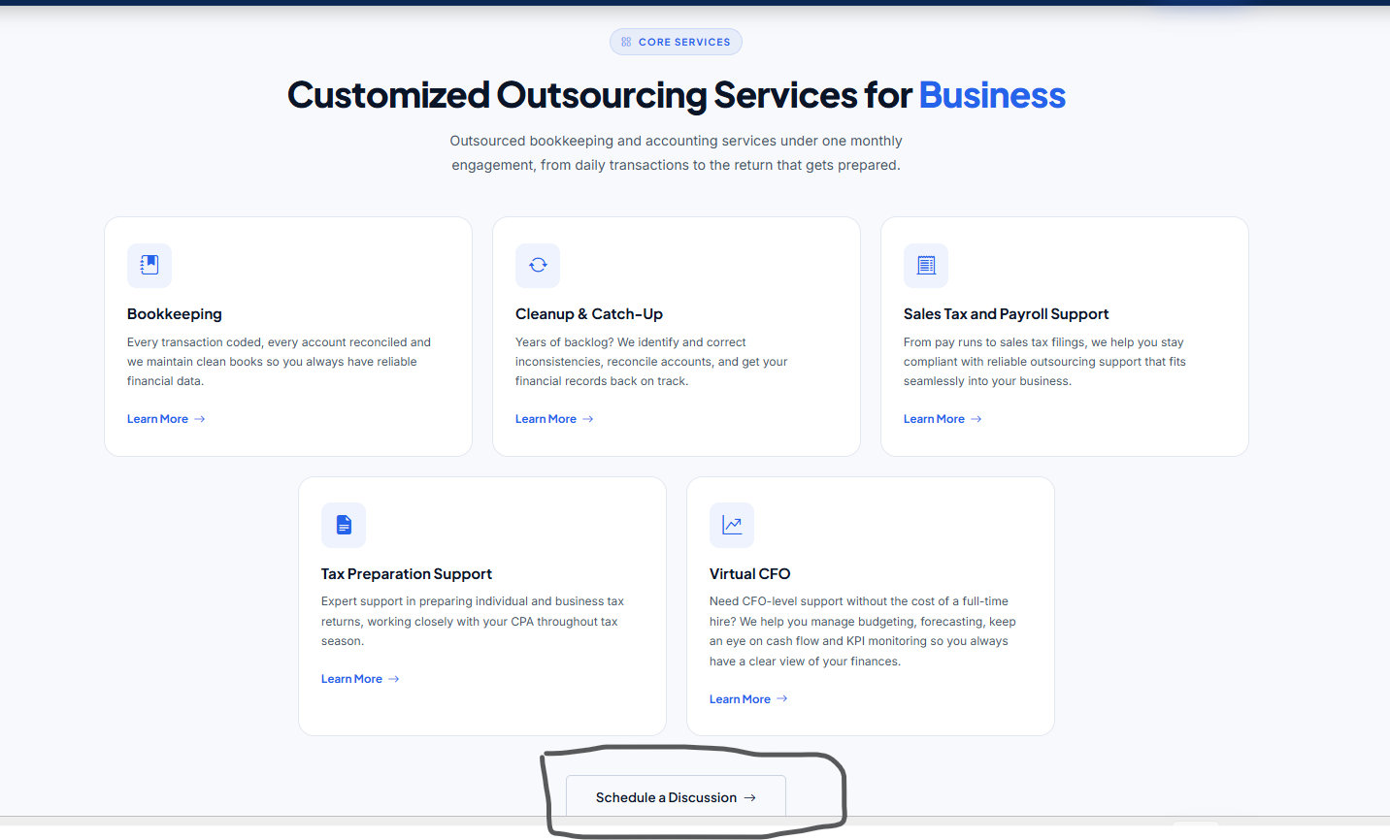 Could you please remove the CTA button from this section? On the homepage, we already have the “Book a Discovery Call” and “Explore Our Services” CTAs. To avoid duplication and maintain a clean, consistent user experience, we think it would be better to remove the CTA from here.
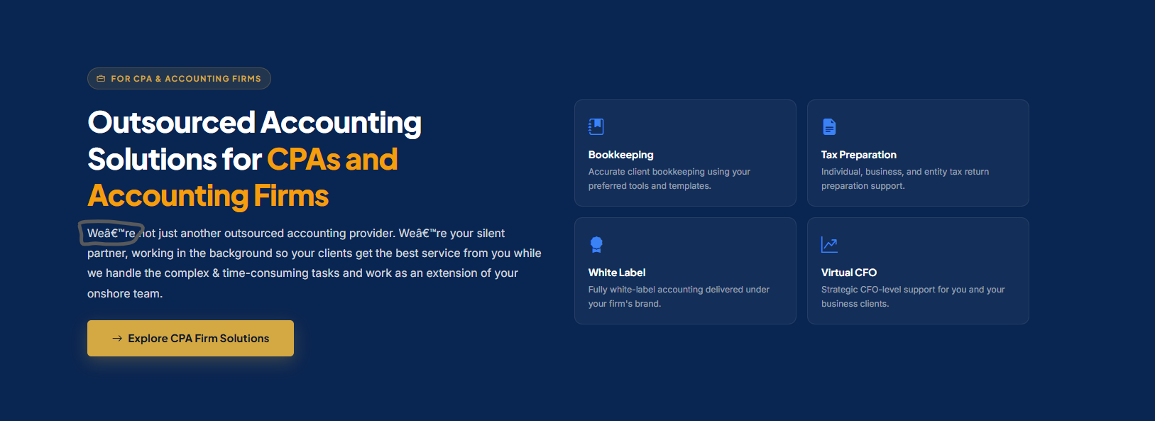
Please remove the CTA button from this section, as it redirects visitors to the main CPA page, which we don’t want. We noticed that separate pages have been created for sections such as “About Us,” “Services,” and “CPA Firms” in the navigation bar. We suggest reviewing and removing these separate pages where the content duplicates information already available on the website. This will help avoid repetition and provide a better user experience. Please feel free to call or text me if you need any clarification. Now, coming to the circled content, we noticed that the same information appears in multiple places, including the “About Us” section on the homepage. To avoid this duplication, could you please review the circled content and streamline its placement? Additionally, could you please update this page in the same way you updated the Core Services section on the homepage? Add a “Learn More” section with links to a to the respective services so visitors can easily explore each service in detail. This will help keep the content organized while making navigation easier for visitors.
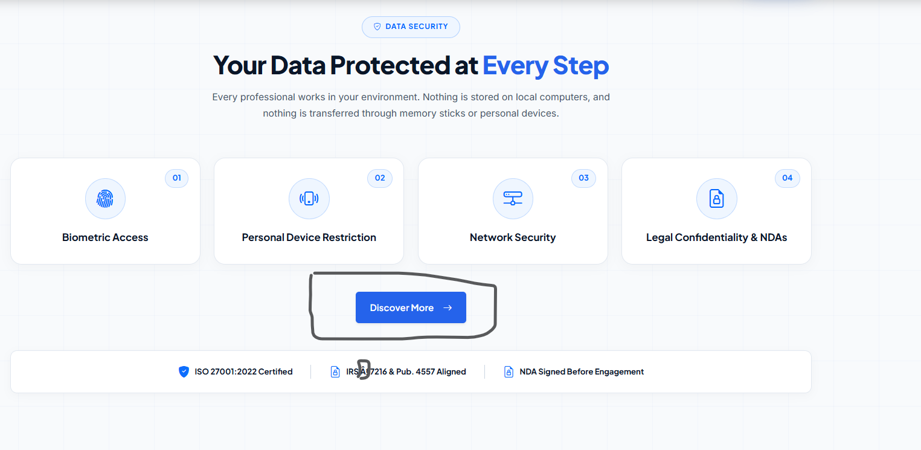
We add here “How We Handle Your data” but it’s changed here I don’t know how can you please change accordingly also show circle mark after IRS A? something like that
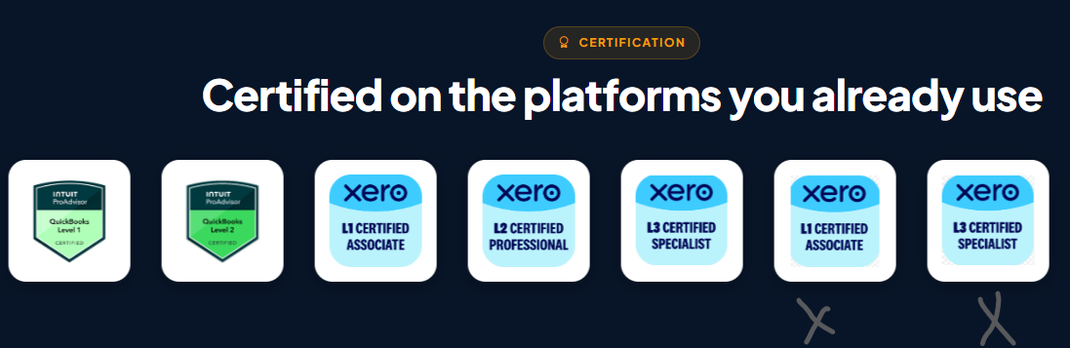
Can you please remove cross mark from here rest keep as it is
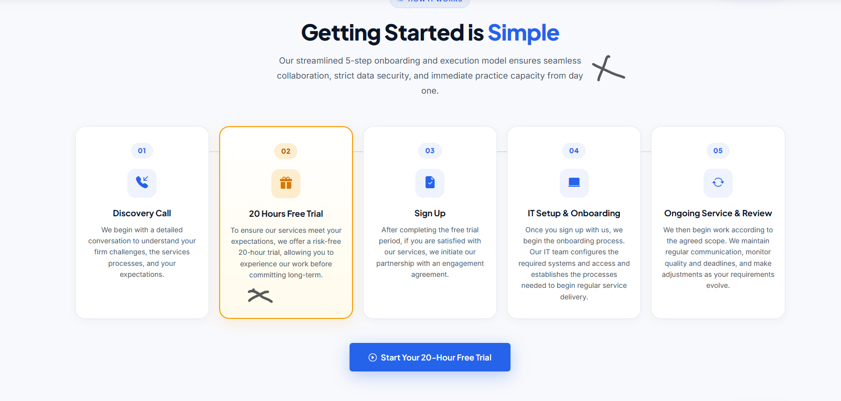
Remove Pera content from here
And for 20-hour free trail find a correction of content below
“To ensure our services meet your expectations, we offer a risk-free 20-hour trial after signing a NDA. This allows you to experience the quality of our work, evaluate our capabilities, and build confidence before making a long-term commitment”.
Please remove from page from fotter “How we handle your data” from here.
Note: I’ve shared all the corrections except for the Services and CPA Firms pages. All the changes have been discussed and finalised by Ehjaz and me. If I’ve missed anything or remember something else that I haven’t mentioned here, I’ll give you a call or send you a message. I’m still working on finding the most suitable content and page layout for the Services and CPA Firms pages.
Once the entire USA website is completed and I’ve reviewed and approved everything, we can move on to the Australia pages. That part should take less time, as only a few pages and some of the content will need to be changed.

